TALKING WITH YOUR

COMPANY ABOUT YOUR

PROFESSIONAL DEVELOPMENT

There are many benefits to continuing your education — including developing skills, knowledge, and connections to accelerate your career. It’s a win-win situation for you and your company. With continued education, you’re a more valuable employee with a greater range of skills and an increased understanding of your business and industry. According to an article in U.S. News & World Report, at least 50% of all American workers get some sort of educational benefit from their jobs — why not capitalize on a way to propel yourself and your company to the next level?

ST. THOMAS EXECUTIVE EDUCATION QUICK FACTS
- 2,125 participants from more than 1,500 companies chose St. Thomas Executive Education.
- 2024 marked 67 years of Executive Education at St. Thomas.
- Most programs are offered on our Minneapolis campus.
- We offer over 30 different open enrollment programs in three categories: specialization, business acumen, and leadership.
- We work with company leaders to deliver high-quality, customized programs tailored to meet unique business objectives.

WITH ST. THOMAS EXECUTIVE EDUCATION, YOU WILL:
- Receive a personalized experience from program exploration to successful completion.
- Gain practical tools from experienced instructors who “practice what they teach”.
- Learn real-world, applicable skills you can use immediately.
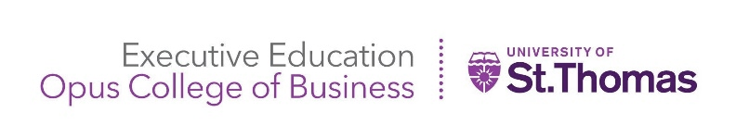
- Network with other professionals and business leaders

HOW TO BRING IT UP

TO YOUR BOSS
Promote your tuition reimbursement as an investment that will directly benefit them. Explain to them how the skills you learn in classes will directly impact their profitability — in terms of money saved as well as money earned.
Focus on the benefits to your company’s bottom line and make sure your boss understands that you plan to stay with the company and use your new skills to benefit them.
Think about your budget cycle. If your company has an excess budget to spend, your boss may be looking for things to spend money on at the end of this budget cycle. It can also be advantageous to ask before the next budget cycle — allowing your request to be factored into the budget.
Pass on your knowledge. Get more out of your new training by sharing your fresh knowledge with others. By offering to host a training session to teach other employees what you’ve learned, your company can get more bang for its buck.
Show you are serious. Offer to sign a contract stating you will meet the attendance requirements of the program, will take on an action learning project related to the program, and/or will stay with the company for at least another term.

LEARN MORE
http://www.stthomas.edu/execed/

(651) 962-4600

